**Creating Your Own Peer-Led ACT Consultation Group**

**ACBS World Conference 2014**

**Friday, June 20th 4:45-5:45 pm**

Paul Guinther, Brian Thompson, Jenna LeJeune, Christeine Terry, Hank Robb,

Sandy Bushberg, Scott Rower, Shadee Hardy, and Anne Shankar

*Portland ACT Peer Consult Group*

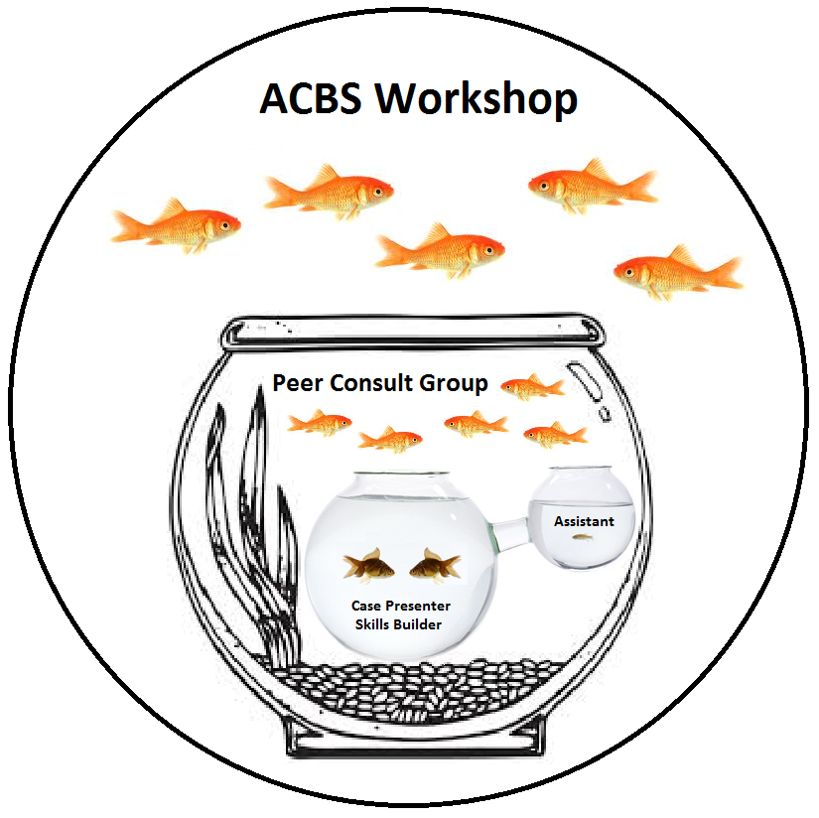

**ACBS Workshop Outline**

**4:45 – 4:50 pm: Workshop Introduction (5 minutes)** (Paul)

* This Handout
  + *ACBS Workshop Outline*
  + *ACT Peer Consult Group Role Descriptions*
  + *Hexaflex Monitor Form*
* Brief introduction to the Workshop
* Fishbowl demonstration of an ACT Peer Consult Group…

**4:50-5:25 pm:** **Demonstration of ACT Peer Consult Group (Time compressed)**

* We typically hold our meetings for two hours; the following demonstration is time compressed to meet the constraints of this 60 minute workshop.
* Our group’s outline, forms, and mission statement can be found at:

http://www.portlandpsychotherapyclinic.com/training/acceptance_and_commitment_therapy_peer_consultation

***Demonstration of “Opening Discussion” portion of the meeting (5 minutes)***

* **Opening exercise** (3 min)
  + ***Purpose****: For the Opening Exercise leader, to practice guiding these types of exercises. For the participants, to help them center and orient toward their values.*
  + *The group leader takes over when the allotted time for the opening exercise has expired. If the Opening Exercise leader would like feedback, it is up to that person to leave enough time.*
* **Introductions, Role Descriptions, and Agenda Setting** (2 min)
  + The Group Leader guides introductions if there are new people in the group--otherwise, skip
  + The Group Leader guides people who have volunteered for roles to describe those roles
    - **Opening Exercise Leader** (Scott)
      * *The Opening Exercise Leader helps people transition into the consult group, and it allows people an opportunity to try out a brief ACT exercise and receive feedback.*
    - **Group Leader** (Brian)
      * *The Group Leader is responsible for maintaining the structure of the group, helping the group transition from activity to activity.*
    - **Process Facilitator** (Anne)
      * *The Process Facilitator helps the group maintain the spirit of ACT, and may note when the group veers from its mission of learning ACT.*
    - **Transition Leader** (Hank)
      * *The Transition leader keeps track of unfinished business from meeting to meeting, and keeps track of who has volunteered for roles for the next meeting.*
  + The group leader sets an agenda for the meeting (e.g., left over business from the last meeting, short consultation questions, announcements, questions, theoretical discussions).
    - *Solicit estimates for the amount of time to devote to each agenda item. Attempt to organize and pace agenda items within the remaining time allotted.*

***Demonstration of “Experiential Skills Building” portion of the meeting (30 min)***

* **Introduce roles** (2 min)
  + **Skills Builder** (Jenna)
    - *The Skills Builder has volunteered to practice some sort of ACT skill, whether it be a specific exercise or focusing on a particular ACT process.*
  + **Case Presenter** (Shadee)
    - *The Case Presenter role plays a client or may bring them self into the role-play in order to give the Skills Builder material with which to practice. The Case Presenter role differs that of typical consult group, in that the emphasis here is on giving the Skills Builder an opportunity to practice ACT and receive feedback. It is not a place for the Case Presenter to bring in a difficult case.*
  + **Assistant to Skills Builder** (Sandy)
    - *The Assistant to the Skills Builder is there in case the Skills Builder would like to consult with someone during the role-play.*
  + **Hexaflex Monitor** (Christeine)
    - *The Hexaflx Monitor quietly tracks ACT processes during the role-play and offers feedback when the role-play is over.*
    - ***Note:***Remind audience they have a copy of the Hexaflex Monitor form that they can use to follow along if they want!
  + *The task of the remaining group members is to silently observe ACT processes at work in the exercise. This is a time to put on your “ACT goggles” and leave any other theoretical modalities at home. It may be helpful to make notes of any questions or comments for the technical discussion.*
* **Role-Play** (15 min)
  + *The Skills Builder practices ACT skills and can ask the Assistant for help, or arrange for the Assistant to “jump in” as needed.*
* **Debriefing** (2 min)
  + *This is a time where the Case Presenter and Skills Builder can share their interpersonal experiences of the role play, and where the other group member can share their appreciation.*
* **Hexaflex Monitor** (3 min)
  + *The Hexaflex Monitor talks about what ACT processes he or she observed.*
* **Technical Discussion** (7 min)
  + *A time for the entire peer consult group to have a technical discussion of relevant ACT skills and techniques. If someone says something ACT inconsistent, this is brought to attention by the Process Facilitator.*
* **Role Assignment / Wrap Up** (1 min)
  + *The Transition Leader recruits volunteers for the various roles for the next meeting.*
  + *Interested parties reconvene for happy hour.*

[END OF FISHBOWL]

**5:25pm - 5:45pm: Open Questions to Audience (20 min)**

Main points of workshop:

* Focus on learning and practicing ACT.
* The emphasis is on giving a Skills Builder an opportunity to practice ACT skills and receive feedback – case consultation is de-emphasized.
* Structure to make it more egalitarian and friendly to new members

**ACT Peer Consult Group: Expanded Role Descriptions**

*Roles are filled on a volunteer basis, and who fills which roles typically changes every meeting. Roles are available to anyone participating in the peer consult group regardless of background, experience, or expertise, making the group more egalitarian.*

**Whole Group Roles**

**Opening Exercise Leader**: Begins the meeting by conducting a brief (no more than 5 minutes) exercise that is based on ACT principles. The general purpose of the opening exercise is to set the tone for the group and to help people transition from one part of their day to the ACT consult group. This is an opportunity to try out a new mindfulness, observer self, or other type of *brief* ACT exercise.

**Group Leader**: Takes over meeting from opening exercise leader. The group leader is responsible for maintaining the structure of the group, primarily by ensuring the group follows the schedule. The group leader should help the group transition to the next activity and alert the group when less than 5 minutes remain in the activity (the exception to this is the opening exercise, where the group leader may want to signal to the open exercise leader that 1 – 2 minutes remain).

**Process Facilitator**: The process facilitator listens for when the group veers from its focus on ACT. For example, it is common for someone to suggest an intervention from another type treatment. In these instances, the process facilitator gently draws attention to this and may ask the individual to restate or translate a concept in ACT terms. The process facilitator is not punitive; rather, he/she keeps the group focused on its stated mission—learning and practicing ACT. May also comment on general process of group (e.g., “I feel some tension in the group right now.”) and link what’s happening in the room to the Mission Statement of the consult group.

**Transition Leader**: Keeps tracks of unfinished business at the end of the first part of the meeting. Writes down roles for the following meeting at the end of the meeting. Emails the roles immediately after the meeting in order that everyone has record of the roles, and sends a reminder emails the week prior to the meeting.

**Experiential Skills Building Roles:**

**Skills Builder**: The skills builder is the person who has chosen to practice ACT during the consultation portion of the group by taking the role of therapist. The purpose of this role is not to solve the case presenter’s presenting concern but to practice ACT skills. The skills builder decides prior to the group (and usually sends an email prior to the group) which ACT skill(s) or process(es) he/she chooses to practice during the experiential skills building portion of the group. For example, the skills builder may want to practice a particular ACT exercise (e.g., Passengers on the Bus). It is up to the case presenter to provide the raw material on which the skills builder can practice and receive feedback from the group. It is important to emphasize that the purpose of this role is to develop and refine the person’s use of ACT in clinical contexts; it is not to provide non-ACT clinical interventions or interpretations.

**Assistant to Skills Builder**: This is a support role where a person is available to assist the skills builder if he/she asks for help practicing his/her ACT skills. Similar to the skills builder role, the assistant to the skills builder role is designed to help the skills builder (and the assistant) practice ACT. The assistant is not responsible for solving the presenting concerns brought by the case presenter, but to help the skills builder and him/herself develop and refine their ACT skills. The assistant is encouraged to be as experiential as possible; for example, rather than offer the skills builder advice or suggestions, the assistant may use ACT to facilitate the process of the skills builder. The Skills Builder may request that the Assistant jump in to provide guidance at any time, or it can be arranged that the Skills Builder will “tap out” when they want assistance.

**Case Presenter**: The case presenter plays the role of the client and thereby brings clinical material on which the skills builder and assistant skills builder will practice their ACT skills. The case presenter role in the ACT consult group differs from that of other consultation groups; instead of providing information for the purpose of receiving help on a clinical issue/topic, the case presenter provides only the most pertinent information needed to help the skills builder practice his/her ACT skills. If the case presenter receives assistance on his/her case, this is an additional benefit but is not the main function of this role. Instead, the case presenter in ACT provides the needed content for the skills builder to use while practicing his/her skills.

**Hexaflex Monitor**: In this role a person notes the core ACT processes (and Creative Hopelessness) that arise during the Skills Building Exercise. Using the Hexaflex Monitor form, the hexaflex monitor silently observes and identifies the ACT processes as they unfold during the Skills Building Exercise. This is a learning process for the hexaflex monitor, in that it helps to build ongoing awareness of core processes as they unfold in the therapy session. After the debriefing of the exercise the hexaflex monitor discusses the ACT processes he/she identified during the exercise. He/she may also offer appropriate corrective feedback on how the skills builder may change or improve their implementation of ACT processes.

**ACT Peer Consult Group: Hexaflex Monitor Form**

